PAM8403 Digital Class D Audio Amplifier kit

Specification:

PAM8403 AMP
- 3W Output at 10% THD with a 4Ω Load and 5V input supply
- Filter less low Quiescent Current and Low EMI
- Efficiency up to 90%
- Short Circuit Protection
- Thermal Shutdown
- Few external components to save space
Speaker:
- Power:3w
- Resistance: 4 Ohm
- Type: Internal magnetic
- Shape: Round
- Magnet Dia: 20.5mm
- Diameter: 40mm
- Height: 20mm
- Material: Aluminium, Rubber, Plastic
- Weight: 32g

Circuit
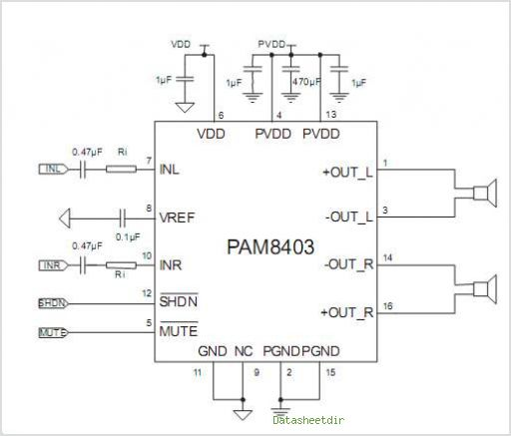
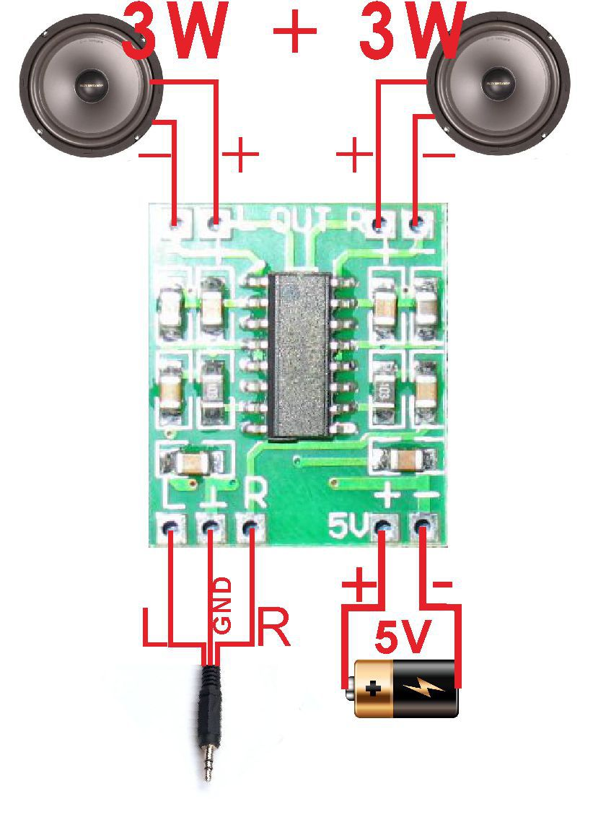
USB cable:
Red wire to +
Black wire to -
Black or green wires to ground white wire goes to L and red the R
If you have the yellow, blue , red cable then:
Yellow wire to GND
Blue wire to R
Red wire to L
Amp works best with mobile phones.

Do not link the negatives together on speakers
Maximum 5v only

